 | 12.1.24 Editors - Geometry Nodes Editor - Header - Add Menu - Grease Pencil - Write
Table of content
Detailed table of content 1
Add menu - Grease Pencil - Write 2
Set Grease Pencil Color 2
Set Grease Pencil Depth 3
Set Grease Pencil Softness 3

Detailed table of content
Detailed table of content
Detailed table of content 1
Add menu - Grease Pencil - Write 2
Set Grease Pencil Color 2
Inputs 2
Grease Pencil 2
Selection 2
Color 2
Opacity 2
Properties 2
Mode 2
Fill 2
Stroke 2
Outputs 2
Color 2
Set Grease Pencil Depth 3
Inputs 3
Grease Pencil 3
Properties 3
Depth Order 3
2D Layers 3
3D Location 3
Outputs 3
Grease Pencil 3
Set Grease Pencil Softness 3
Inputs 3
Grease Pencil 3
Selection 3
Softness 3
Outputs 4
Grease Pencil 4

Add menu - Grease Pencil - Write
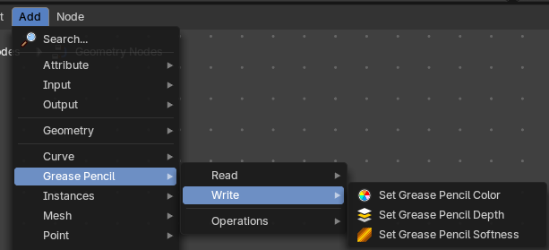
Grease pencil nodes.

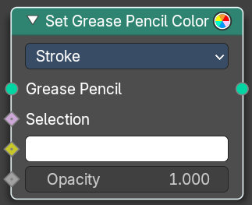
Set Grease Pencil Color
Sets the color and opacity of a grease pencil geometry.

Inputs

Grease Pencil
The grease pencil geometry.

Selection
A selection of the grease pencil geometry.

Color
The color.

Opacity
The opacity.

Properties

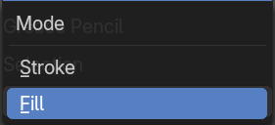
Mode

Fill
Change the fill color.

Stroke
Change the stroke color.

Outputs

Color
The grease pencil output with changed colors.

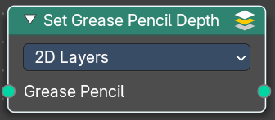
Set Grease Pencil Depth
Set the grease pencil depth order to use. By 2d layers, or by the position in 3d space.

Inputs

Grease Pencil
The grease pencil geometry.

Properties

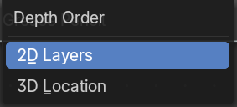
Depth Order

2D Layers
Set the grease pencil depth by the 2d layers.

3D Location
Set the grease pencil depth by the postion in 3d space.

Outputs

Grease Pencil
The grease pencil geometry.

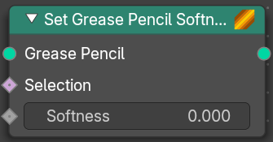
Set Grease Pencil Softness
Adjust the falloff towards the stoke border.

Inputs

Grease Pencil
The grease pencil geometry.

Selection
A selection of the grease pencil geometry.

Softness
The falloff softness. A value of 1 means sharp border. A falloff of 0 means a falloff from the center to the border with a complete transparency at the border.

Outputs

Grease Pencil
The grease pencil geometry.

